RESOLUTION NO.__________

RE: CERTIFICATE OF APPROPRIATENESS UNDER THE
PROVISIONS OF THE ACT OF THE PENNSYLVANIA
LEGISLATURE 1961, JUNE 13, P.L. 282 (53
SECTION 8004) AND BETHLEHEM ORDINANCE NO.
3952 AS AMENDED.

WHEREAS, it is proposed to install signs and lighting at 310 Taylor Street.

NOW, THEREFORE, BE IT RESOLVED by the Council of the City of Bethlehem that a Certificate of Appropriateness is hereby granted for the work.

Sponsored by: (s)

(s)

ADOPTED BY COUNCIL THIS DAY OF

(s)
President of Council

ATTEST:

(s)
City Clerk

HISTORIC CONSERVATION COMMISSION

CASE # 561 – It is proposed to install signs and lighting at 310 Taylor Street
OWNER/APPLICANT: Stephen & Kathleen Elek / Samuele Masotto

The Commission upon motion by Mr. Roeder seconded by Mr. Evans adopted the proposal that City Council issue a Certificate of Appropriateness for the proposed work described herein:
- The proposal to install signs and lighting at 310 Taylor Street was presented by Samuele Masotto.
- Two signs will be installed on the building. On the front façade a double-sided projecting sign will be installed at the former doorway. The sign will have a keystone shape and overall dimensions of 30” x 30”. The sign will be tan with black carved lettering and logo with burgundy pinstripe and accents. One side of the sign will have a Moravian star the read “brew pub” and the other side of the sign will have a dog logo and read “bonn”. All lettering will be Cochin font. The sign will hang from a black metal scroll bracket.
- On the north façade a painted sign will be installed in the recessed panel area as shown on the photograph provided at the meeting. This sign will read “bonn place brewing co.” all in lower case lettering (Cochin font) in black.
- The projecting sign will be illuminated with small spot lights mounted on the bracket similar to the sign at Molinari’s restaurant on E. Third St. A cut sheet must be submitted for the lighting.
- Exterior wall sconces will be installed on the front façade on either side of the garage door and on either side of the entrance door. The sconces will be industrial style. Specifications for the lights must be submitted.
- The motion to approve the proposed work was unanimously approved.

CU: cu
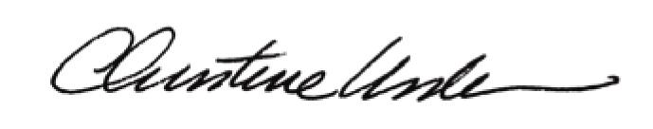

By:

Date of Meeting: August 17, 2015 Title: Historic Officer

